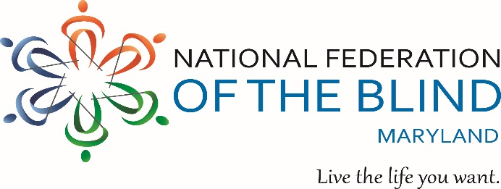
ANNUAL CRAB FEAST
To benefit the John T. McCraw Scholarship Fund
Friday, August 5, 2022 - 6:00 p.m. to 10:00 p.m.
Tall Cedars – 2501 Putty Hill Ave - Parkville, MD 21234
Steamed Crabs, Pit Beef, turkey breast, & Ham – All You Can Eat!
Plus a Buffet of Entrees Including Old Bay wings and
Sausage, Sides, Salad, Cake…
50/50 &
More!
Yuengling and Miller beer
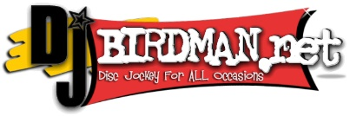
Carbonated Beverages and Coffee
Music, Dancing, Door Prizes

Tickets: $65.00 per person if purchased on or before 7/22/22 OR $70.00 per person
if purchased after 7/22/22. Children 6 and under are FREE.

Purchaser’s Name: ____________________________________________________

Address: ____________________________________________________________

City: ___________________________ State: ____________ Zip: _____________

Phone: ( ) ________________ Email: ________________________________

Number of Tickets Needed: _______ @ $65.00 each OR ______ @ $70.00 each

Amount Due: $_________________ Tickets Sold By: ______________________

Buy or Sell 25 or more tickets and your ticket is FREE!
If you cannot attend, donations are always welcome!
Pay or donate online at: www.nfbmd.org
Make checks payable to: NFBMD
Mail to: NFBMD Crab Feast, 1800 Johnson Street, Suite N1, Baltimore, MD 21230
For additional information: Call (443) 426-4110 or email President@nfbmd.org

