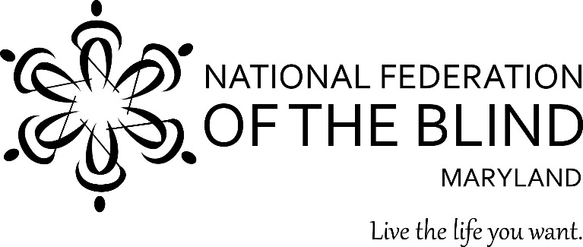
NATIONAL FEDERATION OF THE BLIND OF MARYLAND
2020 BID FOR OPPORTUNITY SCHOLARSHIP DINNER & AUCTION

Make a difference by helping blind students from kindergarten through college on the road to living the lives they want
Support the John T. McCraw Scholarship Fund and and the NFB of Maryland Youth Training Programs
Dine out and join our Bid for Opportunity
Date: Saturday, September 19, 2020
Time: 5:00 TO 9:00 PM
Location: VFW 9619-Morningside
6527 Suitland Road, Morningside MD 20746
Cost: $40 per person.
Enjoy delicious food, entertainment, and an auction for all tastes and budgets.
Reservations must be made by September 10. Each table seats 8.
Make checks payable to the National Federation of the Blind of Maryland
Mail checks to: Debbie Brown, Scholarship Dinner Chairman
11923 Parklawn Drive, #104
Rockville, MD 20852
Or visit nfbmd.org/bidforopportunity to purchase tickets online.
Contact: Debbie Brown at deborahb14@verizon.net, or call (301) 881-1892

